THEORY QUESTIONS
1.
(a)

The diagrams below are illustrations of a set-up used to study the conditions for seed germination. The flasks are kept at 25 ºC during the experiment. Study the diagrams carefully and answer the questions that follow.
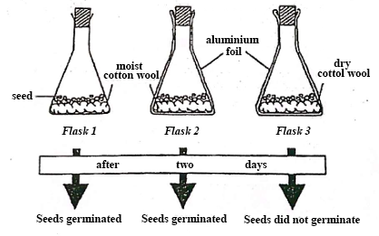
(i)

What conclusion can be drawn from the results of flask 1 and flask 2?
(ii)

What conclusion can be drawn from the results of flask 2 and flask 3?
(iii)

The seedings in flask 2 died after two weeks. What can be the reasons for this occurrence?
(iv)

A candidate concluded that light was an important factor for the germination. Did the candidate make a correct conclusion?
(v)

Give a reason for the answer stated in (iv) and state which of the flasks in the experiment could be used to support your answer.
(b)

The diagram below are illustrations of an experimental set-up. Study the diagrams carefully and answer the questions that follow.
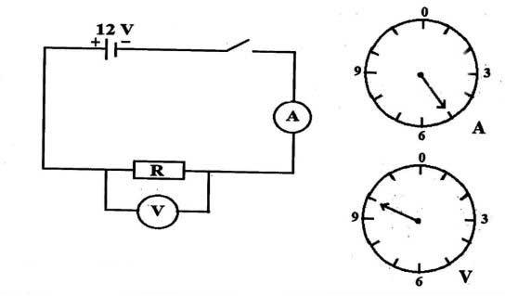
(i)

Name the measuring instrument that is in:
(α)

parallel;
(β)

series;
With the resistor R
(ii)

What quantity does each of the named instruments in (i) measure?
(iii)

Read and record the values as indicated on:
(α)

A in amperes;
(β)

V in volts.
(iv)

Use the values read in (iii) to calculate the value of R.
(v)

State one precaution to be taken in performing this experiment.
(c)

The diagrams below are illustrations of soil.Study the illustrations carefully and answer the questions that follow.
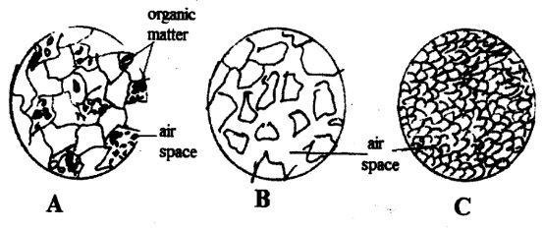
(i)

Identify each of the soil types labelled A, B and C
(ii)

Describe each of the soils under the following properties:
(α)

Particle size
(β)

Air space
(iii)

State two ways of improving soil type B for vegetable cultivation.
(d)

The diagrams below is a set-up for preparation of common salt in the laboratory. Study the diagrams carefully and answer the questions that follow.
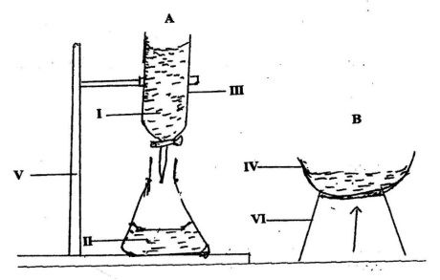
(i)

Name each of the parts labelled IV, V and VI.
(ii)

Name two possible solutions that can react to product salt.
(iii)

Name the process that takes place when the two solution named in (ii) react.
(iv)

Name the process that takes place in the set-up B.
(v)

Write a balanced chemical equation for the reaction between the two solutions named in (ii).
Show Solution
2.
(a)

(i)

State what happens when photosynthesis occurs in a leaf.
(ii)

What is pollination?
(b)

Explain briefly why the mass of lumpy charcoal remains unchanged when ground into powder but the mass of the same lump changes when heated to burn.
(c)

(i)

What is a physical quantity?
(ii)

State two physical quantities
(d)

State two importance each of:
(i)

light;
(ii)

temperature;
in crop production

3.
(a)

(i)

What is hardness of water?
(ii)

Give one example each of a natural source of water that is:
(α)

hard water;
(β)

soft water;
(b)

What is the end-product of the digestion of each of the following?
(i)

Meat;
(ii)

Cassava;
(iii)

Palm-oil;
(c)

Give one effect of each of the following factors considered in vegetable crop production:
(i)

soil type;
(ii)

nearness to market;
(iii)

nearness to source of water;
(d)

(i)

Explain briefly why an eclipse occurs.
(ii)

Name the two types of eclipse

4.
(a)

(i)

Explain the term convection as applied to heat transfer.
(ii)

Give two reasons why convection does not occur in solids
(b)

Give two effects of each of the following soil physical properties on maize cultivation:
(i)

texture;
(ii)

water holding capacity
(c)

Use any three of the following organisms to construct a food chain:
Hawk, grasshopper, man, grass, toad, grasscutter.
(d)

(i)

Consider the following elements and state which element(s) is/are metals:
₁₁Na,₇N,₆C, ₃Li
(ii)

Explain briefly what is observed when pieces of each of the following metals are dropped into two separate test tubes each containing dilute hydrochloric acid:
(α)

magnesium;
(β)

silver.

5.
(a)

State two important components each of the soils that helps:
(i)

Crops to grow well;
(ii)

To maintain good soil structure.
(b)

(i)

Explain how energy in a windmill is obtained
(ii)

State one source of renewable energy.
(c)

(i)

Explain why steel is preferred to iron in building construction.
(ii)

State two ways of preventing rusting.
(d)

State three ways of preventing indigestion.

6.
(a)

State three ways by which the atmosphere in an industrial area is polluted.
(b)

(i)

Write the word equation for each of the following reactions between:
(α)

calcium and oxygen
(β)

nitrogen and hydrogen
(ii)

State the hazard that could be prevented when each of the following protective materials are used in the laboratory:
(α)

gas mask
(β)

goggles
(c)

If a cuboid of weight 100 N, has sides 5 cm by 10 cm, calculate the:
(i)

Area of the cuboid;
(ii)

Pressure exerted by the cuboid when it lies on its side.
(d)

(i)

Explain the term mixed farming.
(ii)

State two advantages of mixed farming.

